Main Menu

Upon running the executable file, the user will be presented with a menu as displayed in the image below.

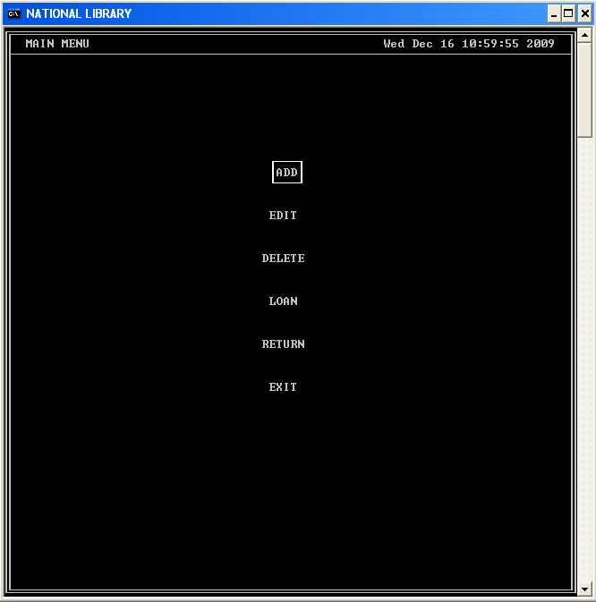

The user will be able to select any item from the menu by navigation it with the navigation keys (up, down and tab). The user selects an item by pressing the “Enter” key when the desired item is hilighted.

